**ADT Lab 7 (10pts)**

**Aggregations**

Name: Atharv Jangam

Semester: Fall 23

**Q1**

**Q2**

**Q3**

**Highlight the questions you are done with to green colour before you submit**

**Setup Instructions:**

1. Login to [Mongo DB Atlas](https://account.mongodb.com/account/login?nds=true&_ga=2.202474643.340387268.1696521987-1624550051.1695827612)

If you have not already created an account [Sign up](https://www.mongodb.com/cloud/atlas/register)

If you already have a cluster and a database created then skip the below steps

1. Under Deployment select Database and create a new database.

1. Select M0 Free option and any region. Name your cluster with your IU username in it (ex- adparab-adtfall2023) and create.

1. Create a user by specifying username and password.

1. Select Cloud and click Add My Current IP Adress.

1. Click Finish and the database cluster should be created.

1. Hit connect and then hit connect using mongodb compass

1. Copy the connection string and replace with your password.

1. Open MongoDB compass and paste the connection string and hit connect.

1. Now create a new database **Airbnb** and name the collection as **Listings.**

1. Load the listings.csv data to your database.

Now your data is loaded. The data that we are working with today is the Airbnb property listing data. We will be writing simple aggregation queries in Mongo DB to analyse this data.

Click in the Aggregations tab and choose the text option.

Write your queries in the left side window and you can see the preview of your results on the right side. Once you are done writing your queries hit run to see all the full output

Post a screenshot of your query and its preview results as shown in the below example-

Number of results is the total results that you get once you run the query. That’s just for you to check your solution. No need to post the screenshot for it.

**Ex. Count of total listings in a particular location (host_location)**

**Query and solution**

Number of results



**References:**

<https://www.mongodb.com/docs/manual/aggregation/>

<https://www.mongodb.com/docs/manual/reference/operator/query/regex/>

<https://www.mongodb.com/docs/manual/reference/operator/aggregation/skip/>

<https://www.mongodb.com/docs/manual/reference/operator/aggregation/limit/>

<https://www.mongodb.com/docs/manual/reference/operator/aggregation/count/>

**Questions:**

1) For each host (host_name) count properties that have ‘Washer’ **and** ‘Dryer’ (amenities)

**Regex to use-**

Use these two regex to filter out properties that have a washer and dryer as amenities:

**/Washer/**

**/Dryer/**

**Hint- Use $match**

Expected solution

Your Solution that includes query-

#Copy your query here

[

{

$match: {

$and: [

{ "amenities": { $regex: /Washer/ } },

{ "amenities": { $regex: /Dryer/ } }

]

}

},

{

$group: {

_id: "$host_name",

count: {

$sum: 1

}

}

}

]

#Paste the screenshot of output here (entire screen)

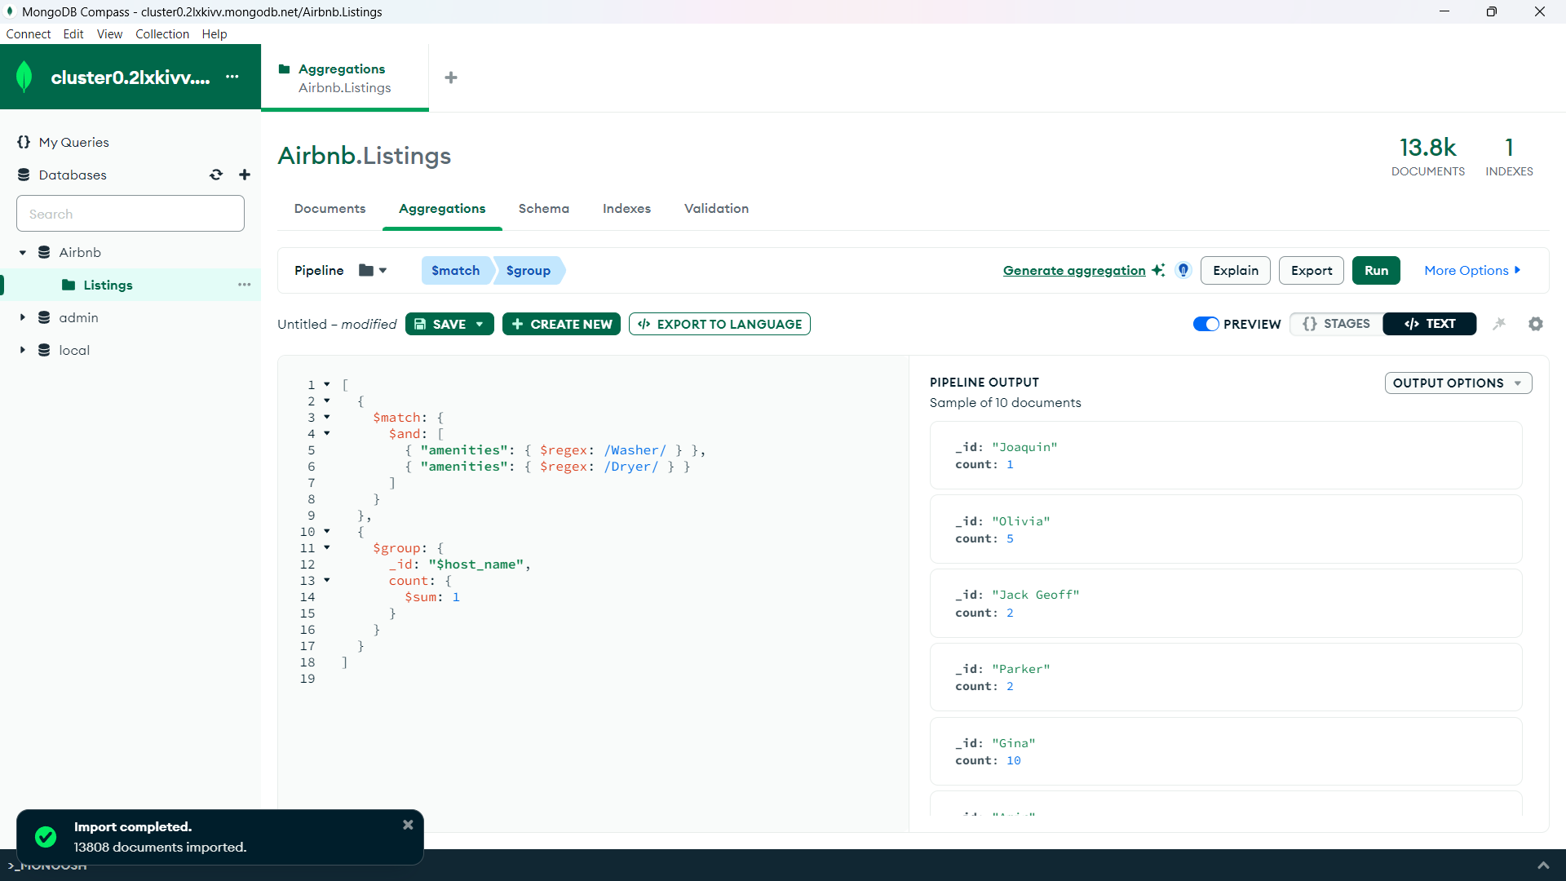

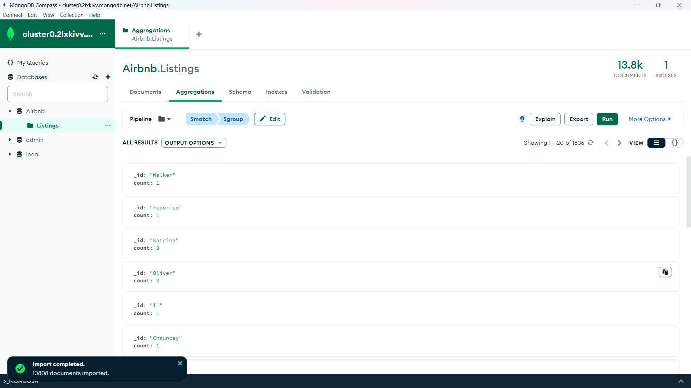

2) Get top 10 host name (host_name) and count of their properties having review score (review_scores_rating) greater than 4 can sort by the count

**Hint: Use $limit**

Expected output

Your Solution that includes query-

#Copy your query here

[

{

$match: {

"review_scores_rating": {$gt: 4}

}

},

{

$group: {

_id: "$host_name",

propertyCount: {$sum: 1}

}

},

{

$sort: {

propertyCount: -1

}

},

{

$limit: 10

},

{

$project: {

host_name: "$_id",

propertyCount: 1,

_id: 0

}

}

]

#Paste the screenshot of output here (entire screen)

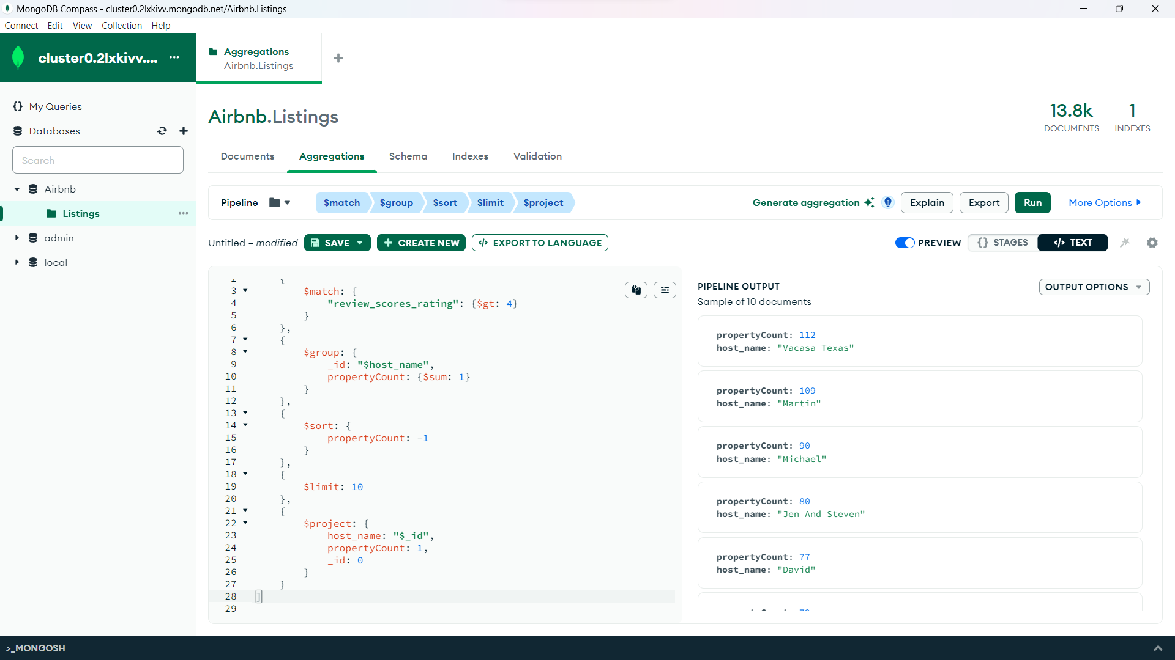

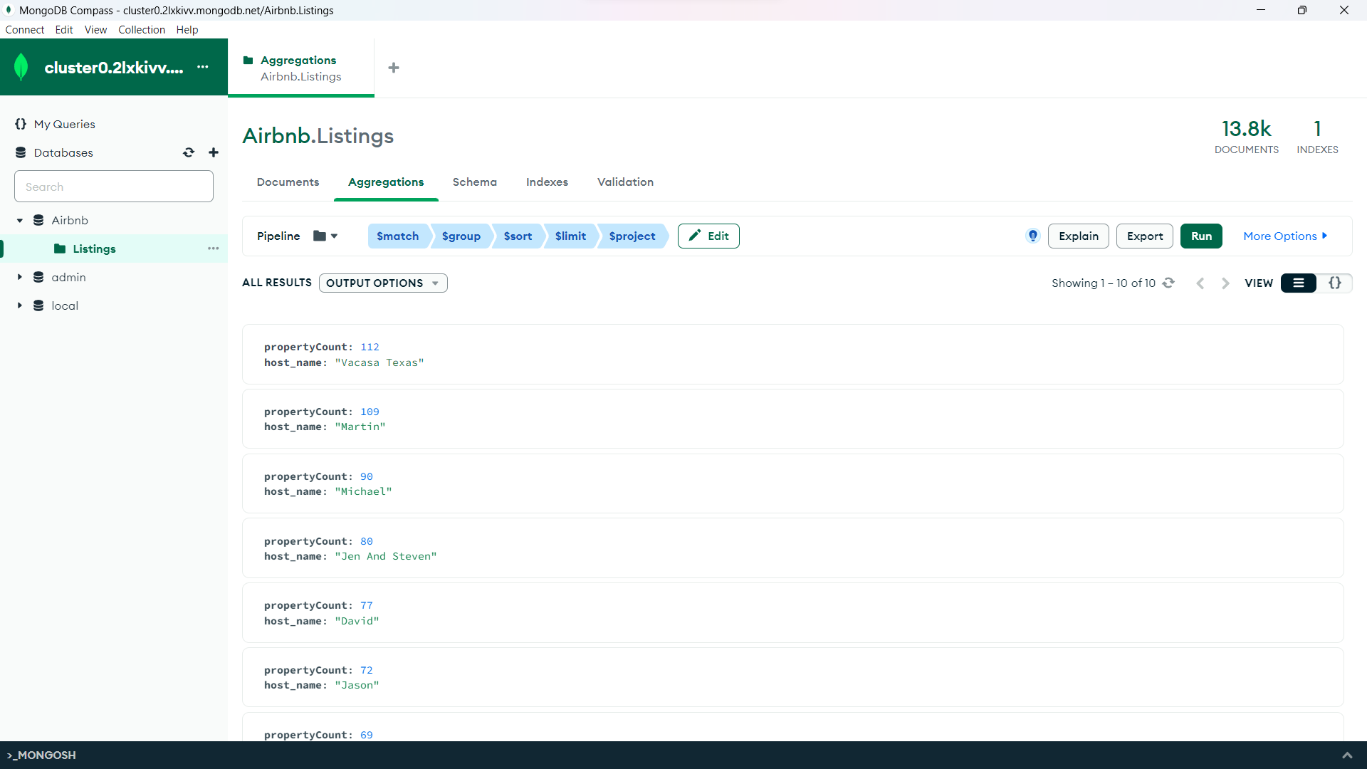

3) List only 21st most expensive hotel in the database

**Hint: Use $limit and $skip**

Expected output

Your Solution that includes query-

#Copy your query here

[

{

$sort: {

"price": -1

}

},

{

$skip: 20

},

{

$limit: 1

}

]

#Paste the screenshot of output here (entire screen)

